Welcome to the FUTURE of work

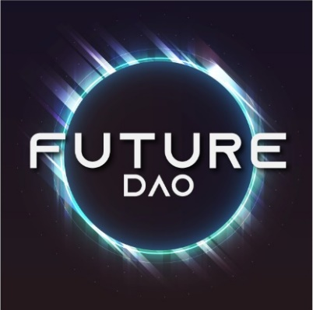

Welcome to the FUTURE DAO

Society is an endeavor in human coordination and organization. Governments organize people and the state to serve and provide for the welfare of its citizens. Politicians organize the constituents they serve. CEOs organize workers and resources to satisfy their customers. However, most of us will never sit in these positions of power, responsible for coordinating humans at scale. This divide between the coordinators and the coordinated has resulted in a disconnect in values and goals between the two groups. This is exactly why, when we try to change things around us it feels like we do not have the power to do so.

**DAOs fix that.**

Decentralized Autonomous Organizations are an effective way to work with like-minded people from all over the world. Think of them as an internet-native organization that is collectively managed and owned by its members. DAOs provide the tools necessary to effectively organize people and resources, making them accessible to everyone. If enough people want to work towards a common goal, they can organize themselves, and work towards changing and shaping the future as they see fit.

What is DAO?

* **Decentralized**, because they are community-owned, grassroots-driven, and loosely organized (in contrast to a hierarchical, tightly-structured centralized org like a bureaucratic agency or company).
* **Autonomous**, because their shared rules and shared treasuries are encoded and automatically enforced on the Ethereum blockchain.(it can be different blockchain)
* **Organizations**, because they’re groups of people that associate and coordinate around specific purposes.

**“DAOs are internet communities with a shared cap table and bank account.”**

- *Cooper Turley*

Ethereum offers immutable and programmable infrastructure that can underpin new kinds of institutions. **The most popular of these institutions so far have been DAOs**.

DAOs are user-owned decentralized communities organized around a common mission. Through smart contracts, these **socio-technical communities** enforce rules and manage their activities transparently on-chain.

A DAO can be **small and informal** or **large and enterprising** and anything in between. In any case, DAOs have socio-economic and socio-political elements and are becoming an increasingly effective way to internationally coordinate labor and resources with other like-minded people.

**

Here are some popular tools and applications that we might use in the FUTURE DAO

* [**Collab.Land**](https://collab.land/) — a token-based community management system
* [**Coordinape**](https://coordinape.com/) — an allocation system for distributing funds to contributors
* [**Discourse**](https://www.discourse.org/) — an open-source forum platform
* [**GitBook**](https://www.gitbook.com/) — a documentation platform
* [**Snapshot**](https://snapshot.org/#/) — a decentralized voting system
* [**SourceCred**](https://sourcecred.io/) — an open-source resource for tracking community contributions
* [**Tally**](https://www.withtally.com/) — a cross-protocol governance dashboard

**Snapshot** is a decentralized voting system. It provides flexibility on how voting power is calculated for a vote. Snapshot supports various voting types to cater to the needs of organizations. Creating proposals and voting on Snapshot is user-friendly and does not cost gas as the process is performed off-chain. In short, Snapshot is an off-chain gasless multi-governance client with easy to verify and hard to contest results.

**Coordinape** is a platform for DAOs to distribute resources easily and fairly to contributors. Community grants, internal salaries, and special projects can all be incentivized and rewarded by the community itself. Instead of cumbersome voting or black box committees, contributors themselves can quickly and transparently reward the value they see being created.

The system can define the rules of participation -- it can grow its network permissionless, set parameters around certain elements of its game mechanics and toggle network visibility, either through centralized admin or internal governance.

FutureDAO also is going to use **POAP**

<https://poap.xyz/>

The POAP (Proof of Attendance Protocol) is a system that event organizers can use to distribute crypto-badges ([ERC-721](https://eips.ethereum.org/EIPS/eip-721) tokens) to people that show up to their event. It also provides an open standard for developers to build on.

POAPs not only have cool designs and allow you to brag your badges with everyone, your collection acts as a digital proof of representation without providing any explicit personal data

this allows everyone to build functionalities on top of the individuality that POAP collections provide without compromising privacy.

TREASURY MANAGEMENT  
<https://gnosis-safe.io/app/#/welcome>  
The FUTURE DAO is going to use **GNOSIS SAFE**

Enter the Multisig. Gnosis Safe is a smart contract wallet running on Ethereum that requires a minimum number of people to approve a transaction before it can occur (M-of-N). If for example you have 3 main stakeholders in your business, you are able to set up the wallet to require approval from all 3 people before the transaction is sent. This assures that no single person could compromise the funds.

On top of that, Gnosis Safe gives you complete self custody over your funds. There is no risk of a bank giving you a hassle for running a crypto business and the smart contract that is deployed is completely trustless and in your control.

TOKEN – ERC20

FDT or FutereDAO Token is going to be our Native utility token , the token is the best way to engage users and economically incentivize for new projects .Our Token is Live on TestNet, (too expensive to lauch on Mainnet) and that a project for the DAO to excute.

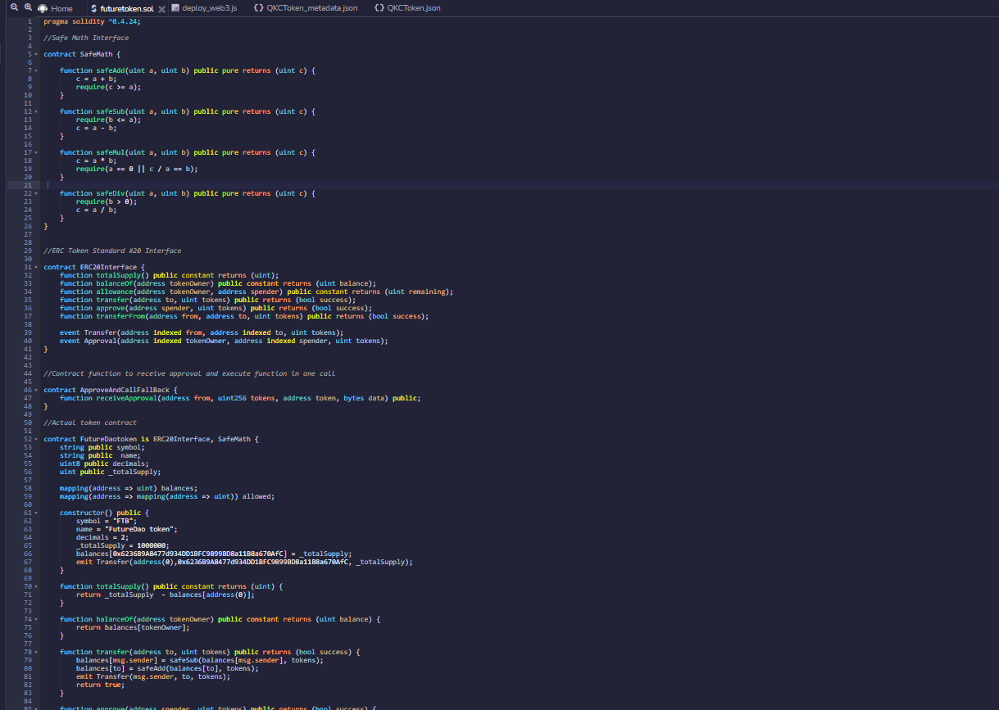

Conclusion

FUTURE DAO is a social DAO built by the community , we aim to create innovate projects and help grow the crypto ecosystem.